**DSA**

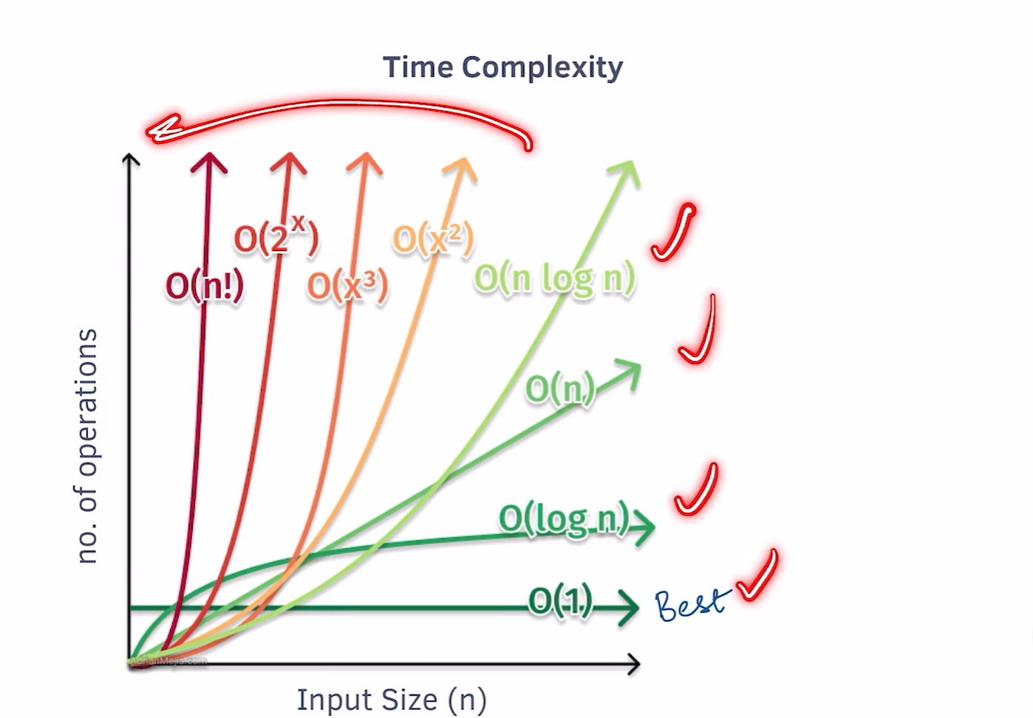

**# Time Complexity**

Time complexity is a crucial concept in computer science that measures how the execution time of

an algorithm grows with the input size. Understanding time complexity helps developers write

efficient code and choose appropriate algorithms for specific problems.

**## Big O Notation**

Big O notation is used to describe the upper bound of an algorithm's time complexity. Common complexities include:

1. O(1) - Constant time

2. O(log n) - Logarithmic time

3. O(n) - Linear time

4. O(n log n) - Linearithmic time

5. O(n^2) - Quadratic time

6. O(2^n) - Exponential time

**## Common Time Complexities with JavaScript Examples**

1. O(1) - Constant Time

Description: The algorithm always executes in the same amount of time, regardless of the size of the input.

Example:

function getFirstElement(arr) {

  return arr[0];  // Always takes constant time to access the first element.

}

Use Case: Accessing a specific index in an array, simple arithmetic operations.

Algorithm: Array indexing

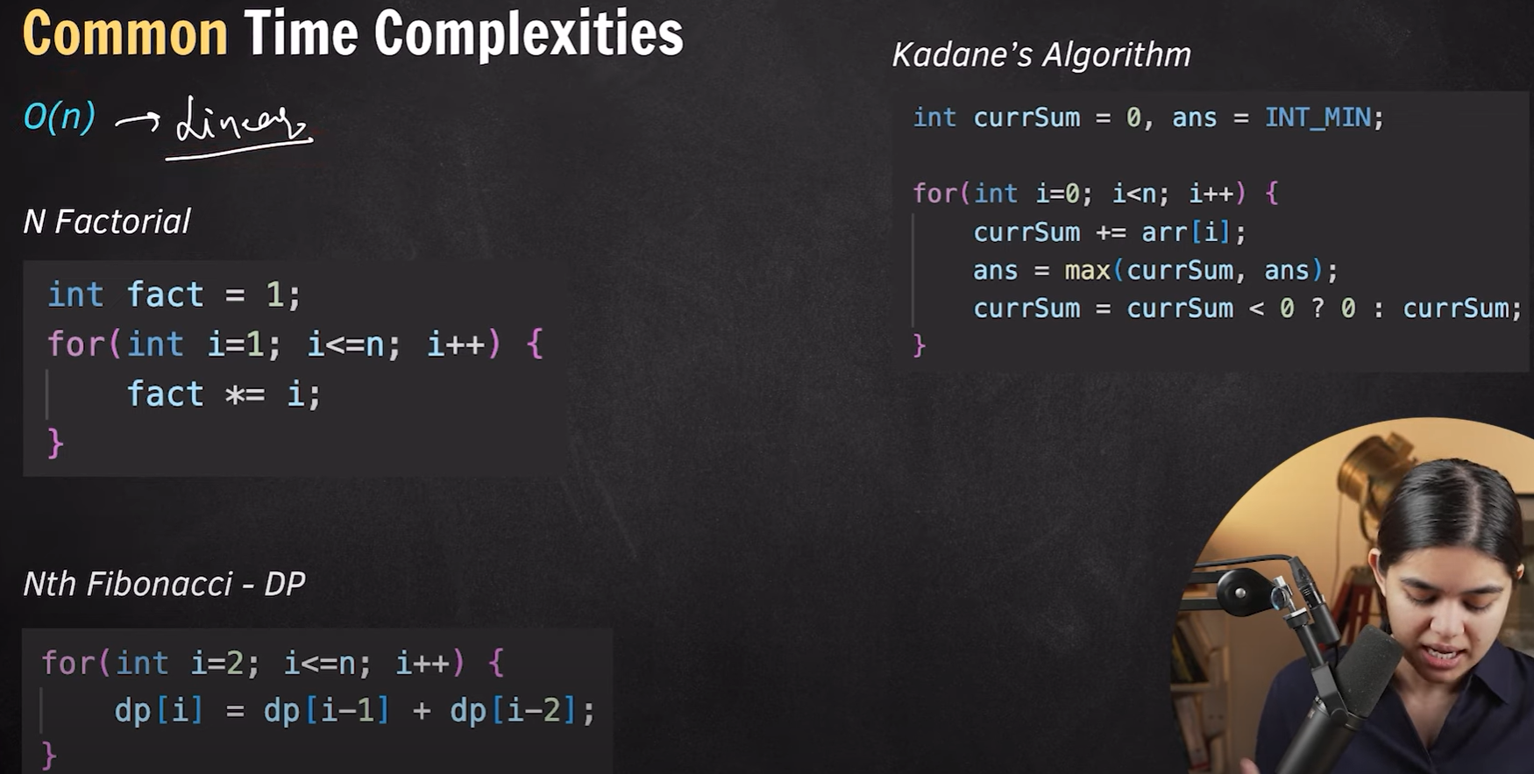

3. O(n) - Linear Time

Description: The time taken by the algorithm increases linearly with the input size.

Example:

function printAllElements(arr) {

  for (let i = 0; i < arr.length; i++) {

    console.log(arr[i]);

  }

}

Use Case: Iterating through an array, single loop traversals.

Algorithm: Linear search

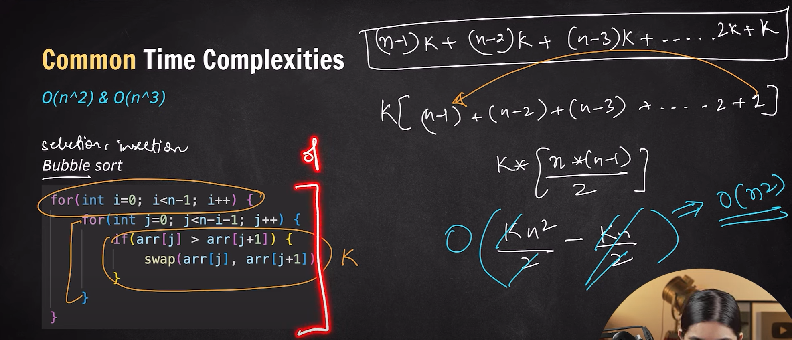

5. O(n²) - Quadratic Time

Description: The algorithm’s time increases quadratically with the input size, often involving nested loops.

Example:

function quadraticExample(n) {

  for (let i = 0; i < n; i++) {

    for (let j = 0; j < n; j++) {

      console.log(i, j);

    }

  }

}

Use Case: Bubble sort, selection sort, insertion sort (naive versions).

Algorithm: Bubble sort, Selection sort

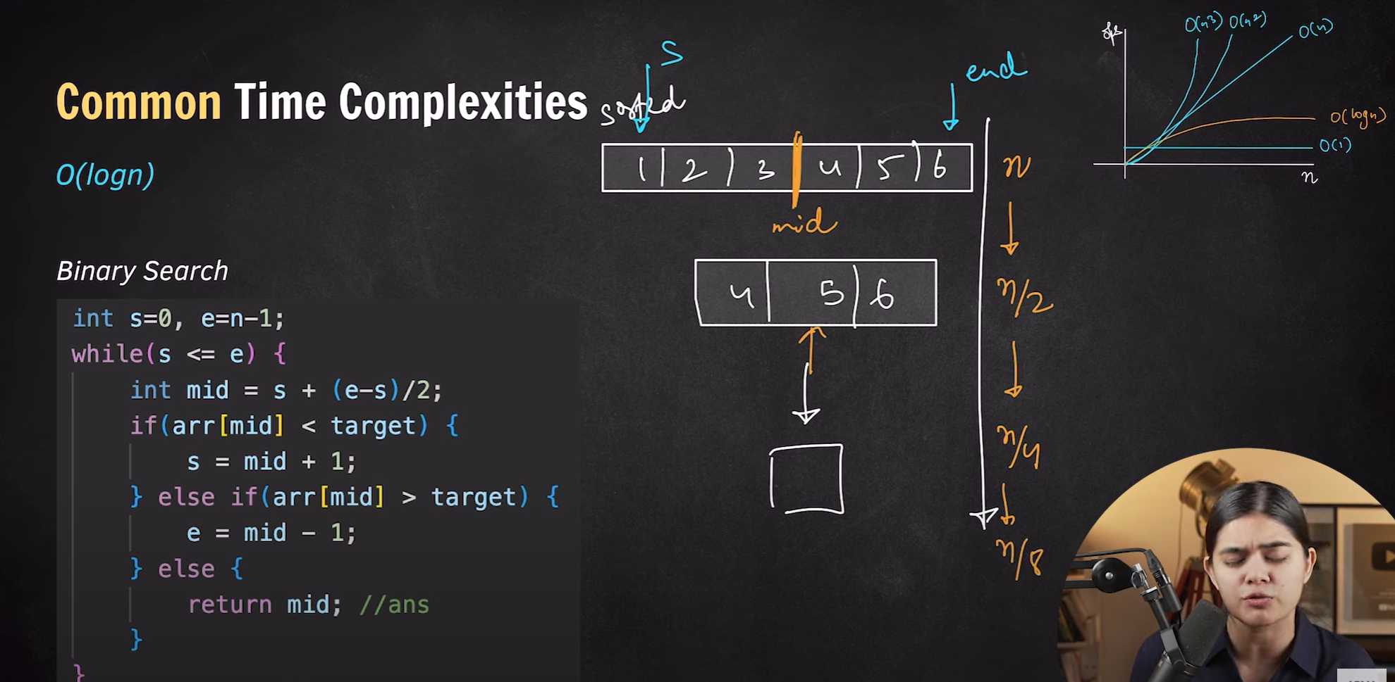

2. O(log n) - Logarithmic Time

Description: The algorithm reduces the problem size by a factor in each step (usually by half).

Example:

function logExample(n) {

  while (n > 1) {

    n = Math.floor(n / 2);

  }

  return n;

}

Use Case: Binary search, balanced tree operations (insertion, deletion, search).

Algorithm: Binary search

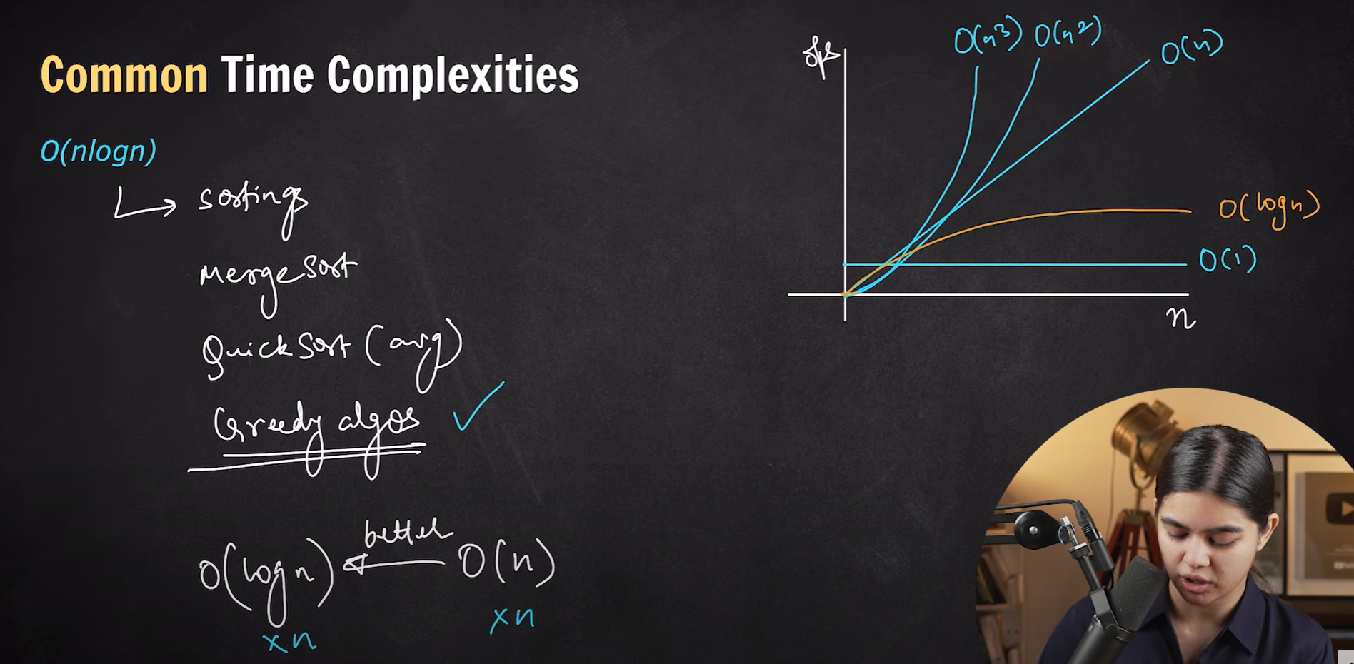

4. O(n log n) - Linearithmic Time

Description: The algorithm performs an O(log n) operation n times. Common in efficient sorting algorithms.

Example:

function linearithmicExample(n) {

  for (let i = 1; i < n; i++) {

    let j = i;

    while (j > 1) {

      j = Math.floor(j / 2);

    }

  }

}

Use Case: Merge sort, quicksort (on average), and heap sort.

Algorithm: Merge sort, Quicksort

6. O(2ⁿ) - Exponential Time

Description: The time taken doubles with each addition to the input data set, usually in recursive solutions.

Example:

function exponentialExample(n) {

  if (n <= 1) return 1;

  return exponentialExample(n - 1) + exponentialExample(n - 1);

}

Use Case: Solving problems with recursion and no memoization, like the naive Fibonacci sequence, subset problems.

Algorithm: Naive Fibonacci sequence

**BINARY SEARCH**

The **Binary Number System** is a base-2 numeral system, which means it uses only two digits: **0** and **1**. It is the fundamental language of computers and digital systems because all operations within a computer are performed using these two states (on/off or high/low voltage).

**Key Points:**

1. **Digits and Base**:
   * **Digits**: Binary uses two digits: 0 and 1.
   * **Base**: The binary system has a base of **2**.
2. **Place Value**: Each binary digit (bit) has a place value that is a power of 2, starting from 2⁰ on the right. For example:
   * 1011 in binary is calculated as:
     + 1×23+0×22+1×21+1×20=8+0+2+1=111 \times 2^3 + 0 \times 2^2 + 1 \times 2^1 + 1 \times 2^0 = 8 + 0 + 2 + 1 = 111×23+0×22+1×21+1×20=8+0+2+1=11 (in decimal)
3. **Conversion**:
   * **Binary to Decimal**: Multiply each bit by 2 raised to the power of its position, then sum the results.
   * **Decimal to Binary**: Repeatedly divide the decimal number by 2, noting the remainders, and read the remainders from bottom to top.

To convert Decimal Number to Binary form.

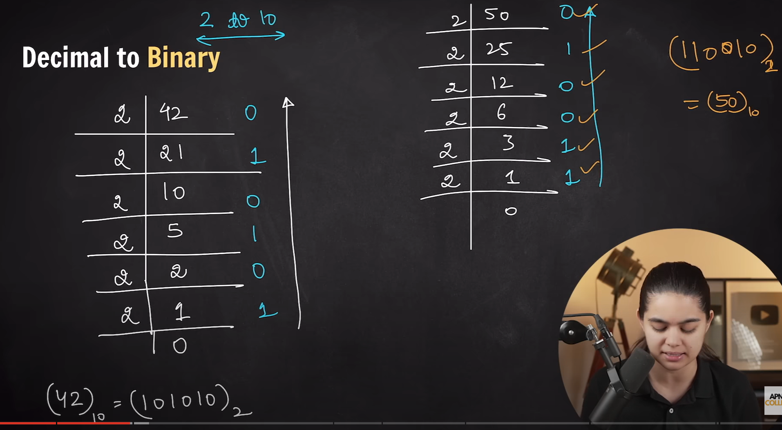

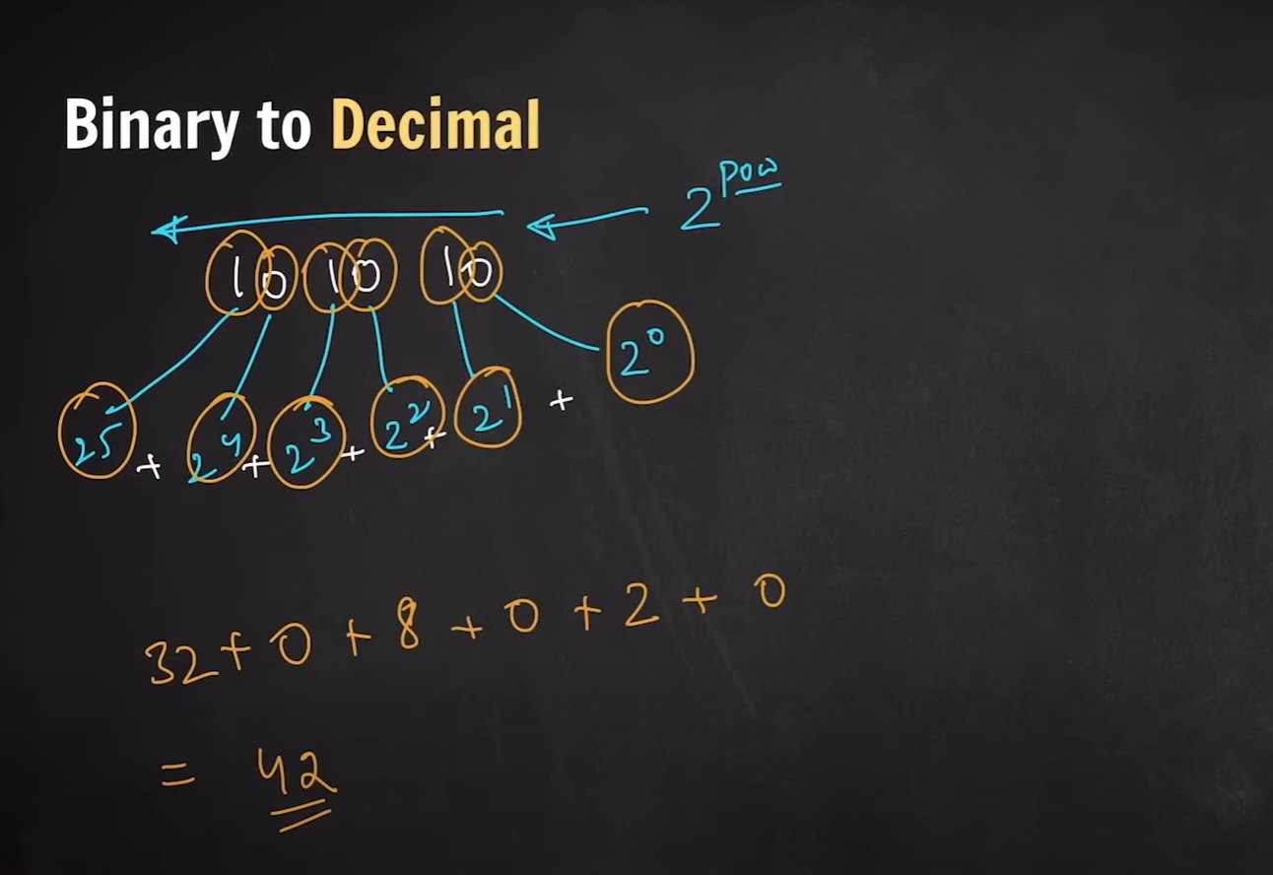

Even we can find binary form of decimal number

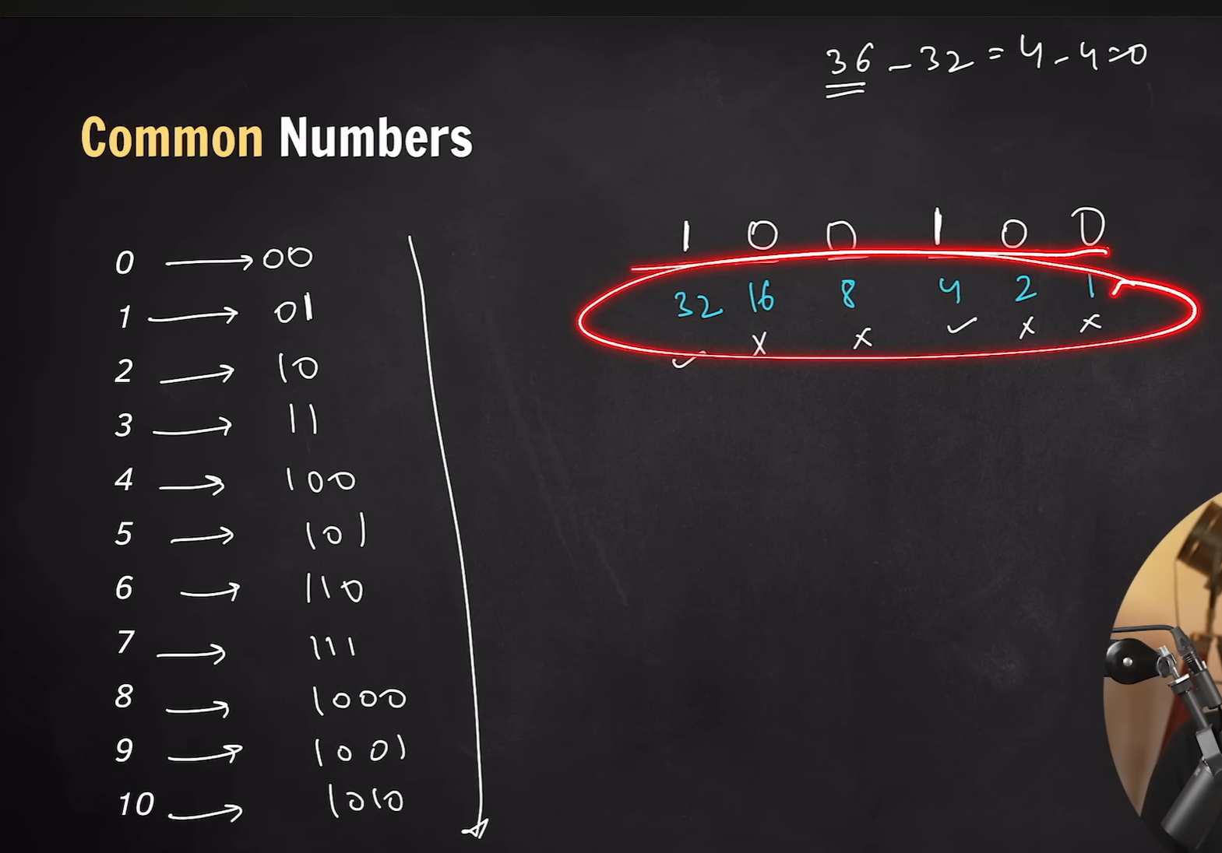

How it is store if you have interger value it allocates you 4bytes which is equal to 32 bytes

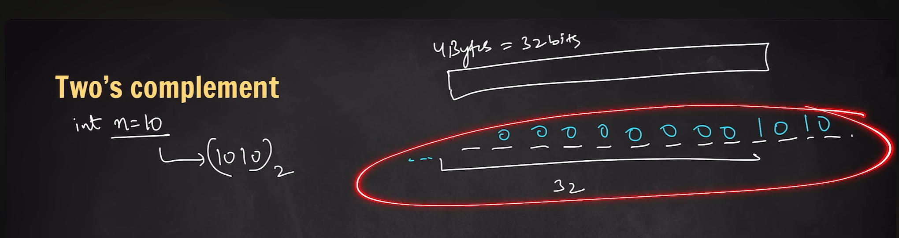

For negative number method is different

It will check msb (Most significant Bit) + or –

Flip all binary number and add +1

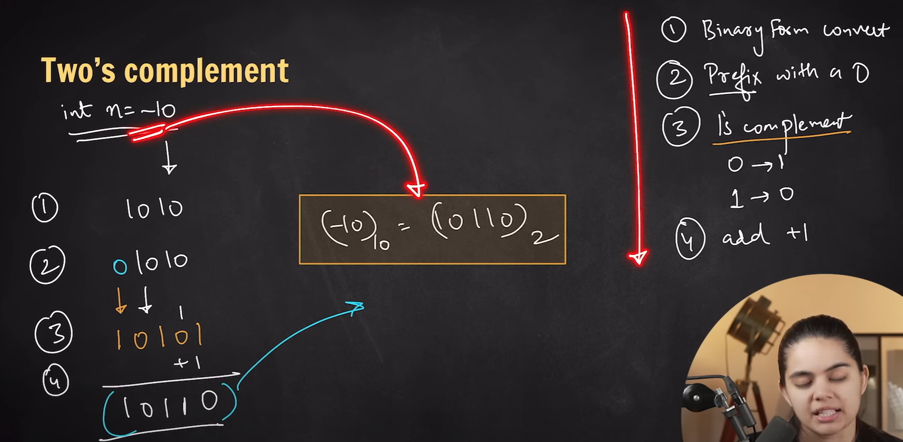

To covert binary to decimal for negative number 10101

First 1 number decides it is binary or not .If yes then add +1.  
  
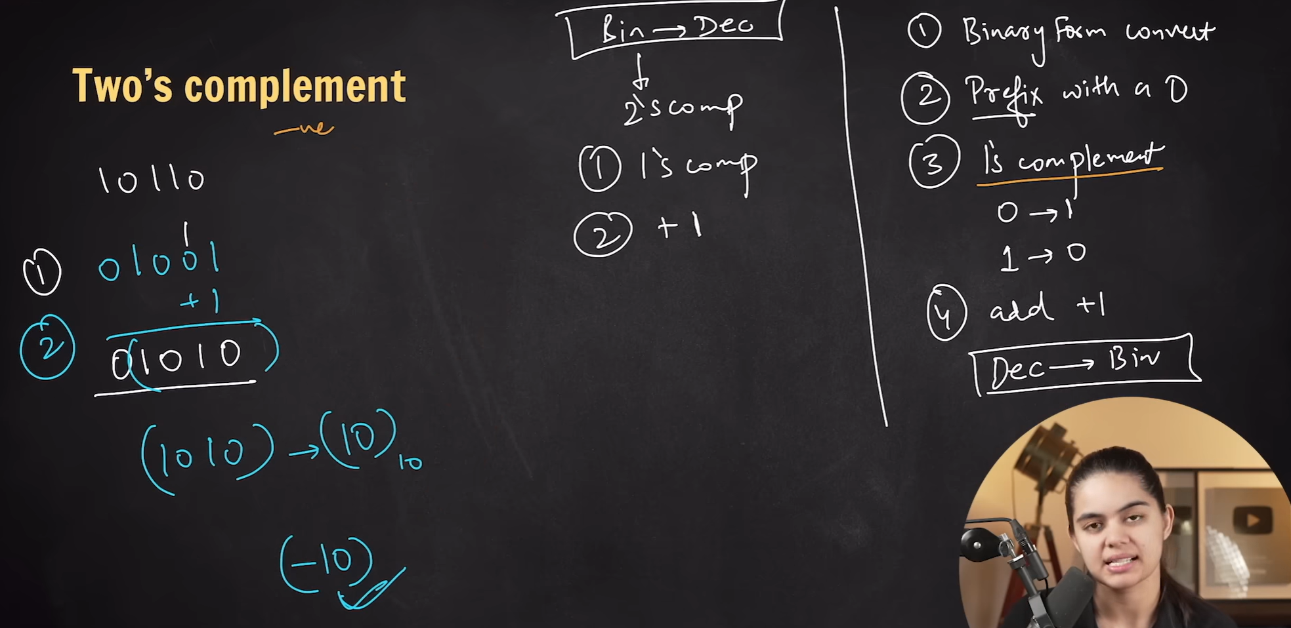

1. **Arithmetic Operations**:
   * **Addition**: Follows simple rules, similar to decimal addition:
     + 0 + 0 = 0
     + 0 + 1 = 1
     + 1 + 1 = 10 (carry 1 to the next higher bit)
   * **Subtraction**: Uses borrowing similar to decimal subtraction.
   * **Multiplication**: Follows standard multiplication rules but is simpler due to only 0s and 1s.
2. **Applications**:
   * Used in **computers**, **digital circuits**, and **communication systems**.
   * All data in computers (text, numbers, images, etc.) is stored in binary format.

**Binary in Computing:**

* **Bit**: The smallest unit of data in a computer, represented as 0 or 1.
* **Byte**: A group of 8 bits.
* **Data Representation**: Computers use binary to represent all types of data, including numbers, characters, and instructions.

This simplicity in the binary system allows for efficient processing in electronic circuits, where devices can easily represent the two binary states (on/off).

**Difference Between Binary and Decimal Number Systems**

| **Feature** | **Binary Number System** | **Decimal Number System** |
| --- | --- | --- |
| **Base (Radix)** | Base 2 (uses 2 digits: 0 and 1) | Base 10 (uses 10 digits: 0-9) |
| **Digits Used** | 0, 1 | 0, 1, 2, 3, 4, 5, 6, 7, 8, 9 |
| **Place Value** | Powers of 2 (2⁰, 2¹, 2², etc.) | Powers of 10 (10⁰, 10¹, 10², etc.) |
| **Representation** | Used mainly in computers and digital systems | Used in everyday counting and calculations |
| **Ease of Use for Humans** | Less intuitive for humans | Intuitive and easy for humans to understand |
| **Conversion to Decimal** | Binary to decimal conversion requires calculations based on powers of 2 | Decimal is natural for humans, no conversion needed |
| **Example (Number 11)** | **Binary**: 1011 (1×2³ + 0×2² + 1×2¹ + 1×2⁰) = 11 in decimal | **Decimal**: 11 (1×10¹ + 1×10⁰) |
| **Arithmetic Operations** | Simpler due to only two digits (0 and 1) | Standard arithmetic with 10 digits |
| **Applications** | Used in computers, digital electronics, and programming | Used in daily life, accounting, finance, etc. |

**Summary:**

* **Binary** is a **base-2** system ideal for digital devices because it only uses **0s and 1s**.
* **Decimal** is a **base-10** system that is more intuitive and commonly used by humans for everyday counting.

**Bitwise Operator**

A **bitwise operator** is an operator that performs operations on individual bits of binary numbers. These operators work directly at the binary level, manipulating the bits of data, which makes them efficient for tasks like bit-level calculations in programming and hardware interfacing.

**Common Bitwise Operators:**

1. **AND (&)**:
   * Compares each bit of two numbers and returns **1** if both bits are **1**, otherwise returns **0**.
   * Example:

sql

Copy code

5 (binary: 0101)

3 (binary: 0011)

--------------

5 & 3 = 1 (binary: 0001)

1. **OR (|)**:
   * Compares each bit of two numbers and returns **1** if **at least one** of the bits is **1**.
   * Example:

sql

Copy code

5 (binary: 0101)

3 (binary: 0011)

--------------

5 | 3 = 7 (binary: 0111)

1. **XOR (^)**:
   * Compares each bit of two numbers and returns **1** if the bits are **different**, otherwise returns **0**.
   * Example:

sql

Copy code

5 (binary: 0101)

3 (binary: 0011)

--------------

5 ^ 3 = 6 (binary: 0110)

1. **NOT (~)**:
   * Inverts all bits of a number, turning **1s** to **0s** and **0s** to **1s**. It is also called a **bitwise negation** or **complement**.
   * Example:

vbnet

Copy code

5 (binary: 0101)

~5 = -6 (binary: 1010 in 2's complement form)

1. **Left Shift (<<)**:
   * Shifts the bits of a number to the **left** by a specified number of positions, filling the rightmost bits with **0s**. Each shift left multiplies the number by 2.
   * Example:

less

Copy code

5 (binary: 0101)

5 << 1 = 10 (binary: 1010)

1. **Right Shift (>>)**:
   * Shifts the bits of a number to the **right** by a specified number of positions. It discards the rightmost bits and fills the leftmost with the sign bit (for signed integers).
   * Example:

less

Copy code

5 (binary: 0101)

5 >> 1 = 2 (binary: 0010)

**Use Cases:**

* **Bitwise operations** are commonly used in low-level programming, such as:
  + Setting, clearing, or toggling specific bits (e.g., bitmasking).
  + Optimizing memory usage.
  + Performing fast mathematical calculations.
  + Data compression and encryption algorithms.

VECTOR

In the context of **Data Structures and Algorithms (DSA)**, a **vector** is an advanced, dynamic array that can change its size automatically as elements are added or removed. Vectors are often implemented in languages like C++ (std::vector) and Java (ArrayList), and provide a more flexible alternative to static arrays.

**Arrays**

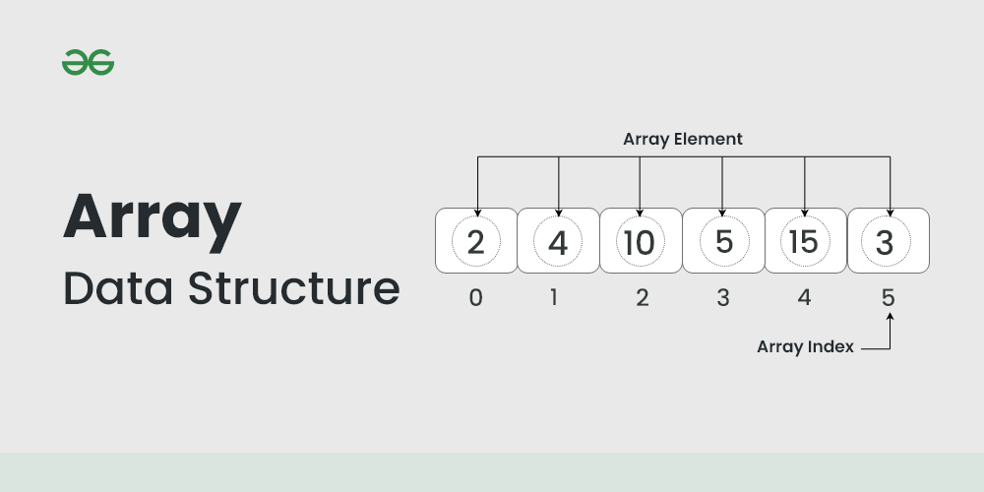

**Advantages of Arrays:**

* **Fast access due to indexing.**
* **Easy to implement and use.**

**Disadvantages of Arrays:**

* **Fixed Size: In static arrays, the size must be known beforehand.**
* **Costly Insertion and Deletion: Inserting or deleting elements at positions other than the end requires shifting, which is time-consuming (O(n)).**

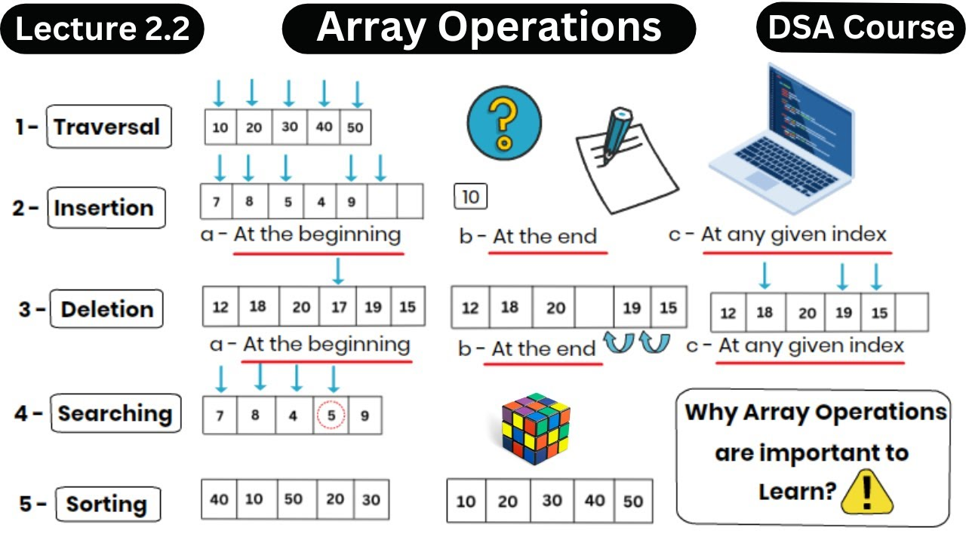

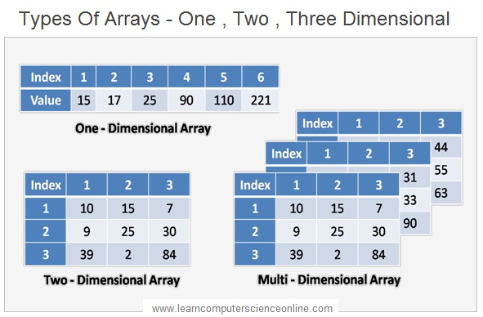

**Kadens**

**Brutforce**

**Moores algo**

**---------------------------------------------------------------Linked List----------------------------------------------**

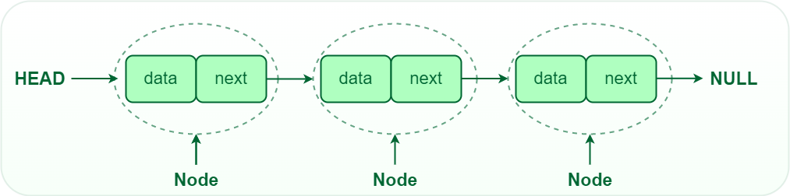

**What is a Linked List?**

**A linked list is a linear data structure that consists of a series of nodes connected by pointers. Each node contains data and a reference to the next node in the list. Unlike arrays, linked lists allow for efficient insertion or removal of elements from any position in the list, as the nodes are not stored contiguously in memory.**

**Array over linked list**

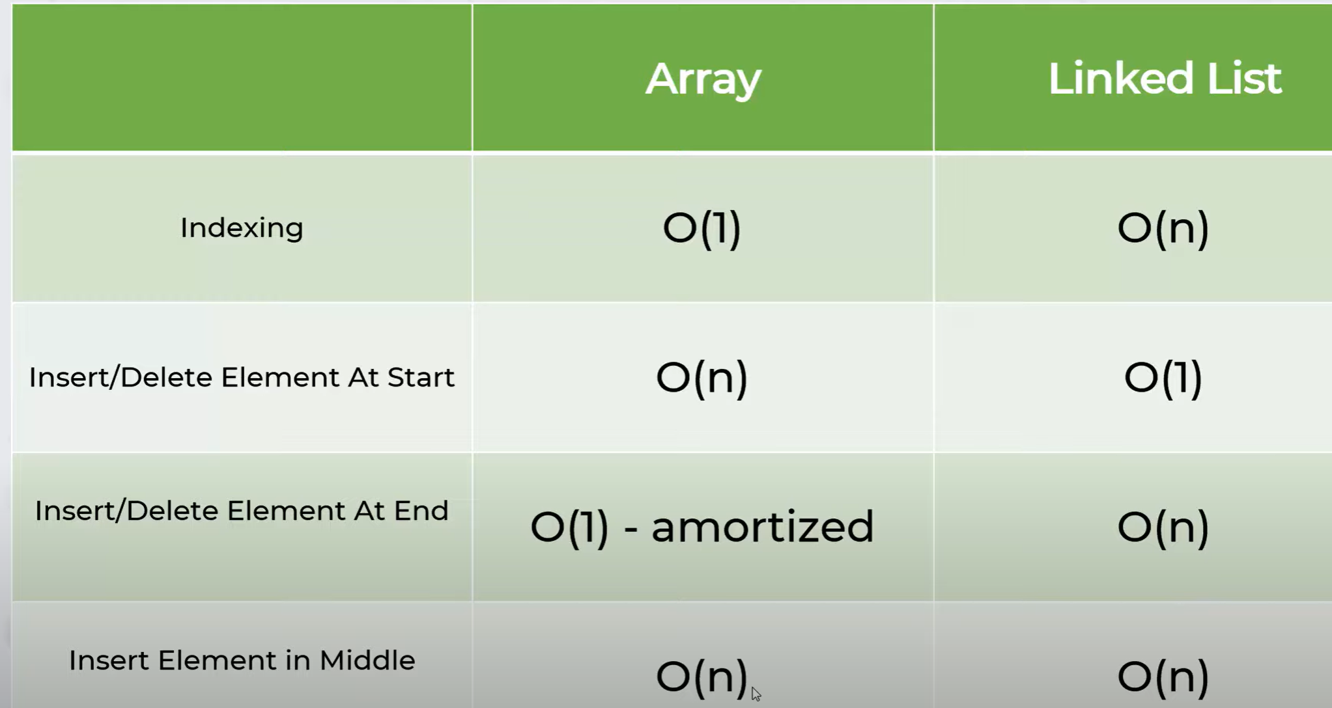

**USES**• Music playlists

• Browser history

• Image viewers (for navigation)

• Operating system task scheduling

[**Types of Linked List**](https://www.geeksforgeeks.org/types-of-linked-list/)

[**Singly Linked List**](https://www.geeksforgeeks.org/data-structures/linked-list/singly-linked-list/)

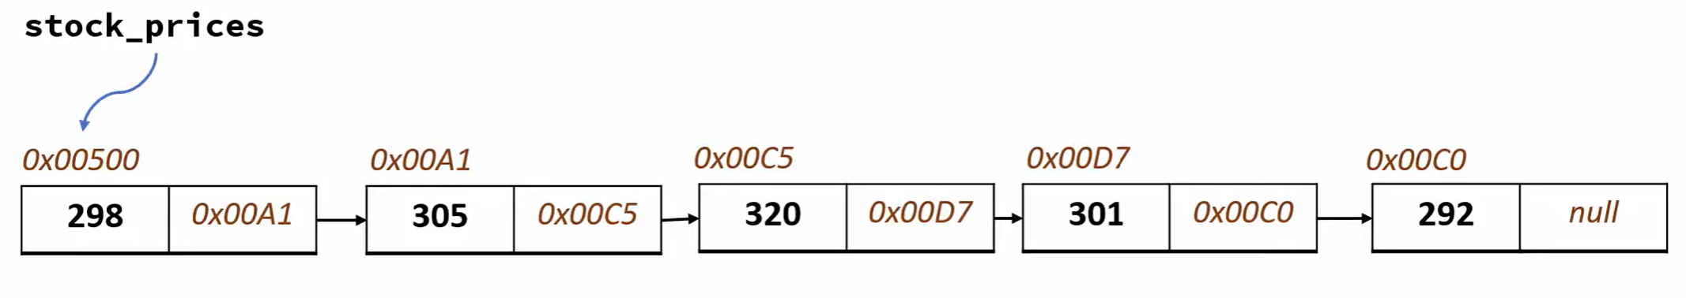

[**Doubly Linked List**](https://www.geeksforgeeks.org/doubly-linked-list/)

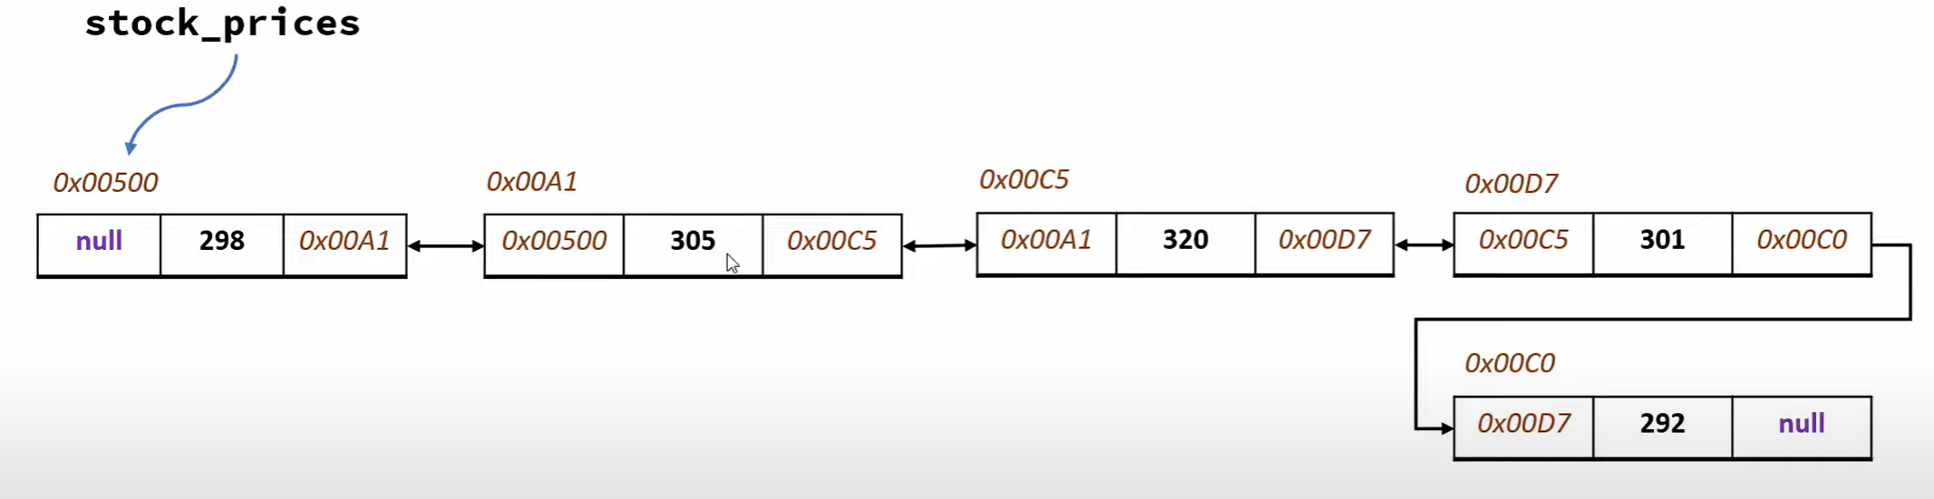

[**Circular Linked List**](https://www.geeksforgeeks.org/circular-linked-list/)

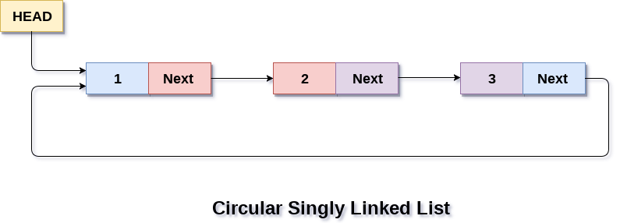

[**Circular Doubly Linked List**](https://www.geeksforgeeks.org/introduction-to-circular-doubly-linked-list/)

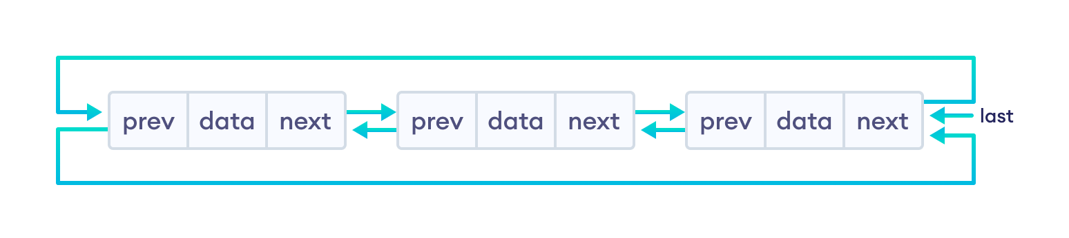

**Stack**

**Stacks are last-in-first-out (LIFO) structures**– The first element added to a stack is the last one to be removed and the last element added to a stack is the first to be removed.

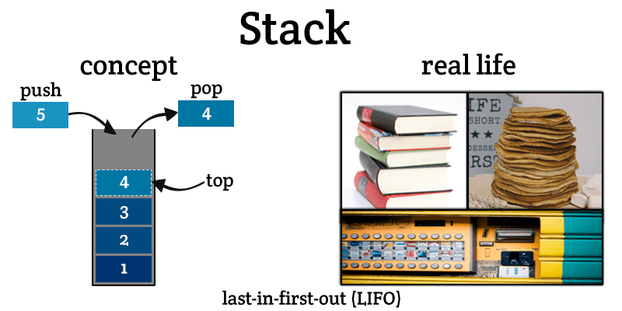

Operations on stack:

**– Push** – Pushes (stores) an element on the stack.

*How it works*: Checks if the stack is full. If it is full, produces an overflow error and exit. If the stack is not full, then increments top to point the next empty space. Adds data element to the stack location, where the top is pointing and returns success.

**– Pop** – Removes (accesses) an element from the stack.

*How it works:* Checks if the stack is empty. If it is empty, produces an underflow error and exits. If the stack is not empty, then accesses the data element at which the top is pointing. Decreases the value of top by 1 and returns success.

* Stacks:
  + Backtracking
  + Expression conversion and parsing
  + Undo command

**QUEUE**

**Queues are first-in-first-out (FIFO) structures** – The first element added to a queue is the first to be removed and the last element to be added to a queue will be the last to be removed.

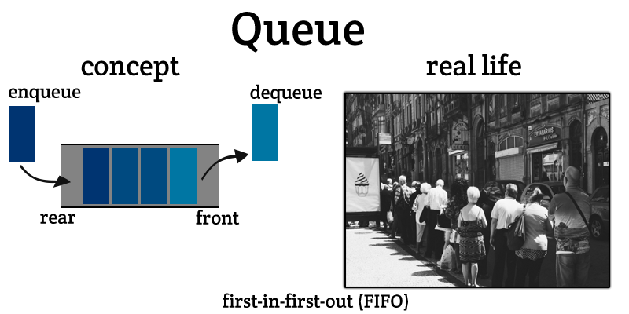

Operations on queue:

– **Enqueue**− Adds (stores) an item to the queue.

*How it works*: Checks if the queue is full. If the queue is full, produces overflow error and exit. If the queue is not full, increments the rear pointer to point the next empty space. Adds data element to the queue location, where the rear is pointing and returns success.

– **Dequeue** − Removes (accesses) an item from the queue.

*How it works*: Checks if the queue is empty. If the queue is empty, produces underflow error and exit. If the queue is not empty, accesses the data where the front is pointing. Increments front pointer to point to the next available data element and returns success.

Two pointers are used to refer the front and rear end of the queue.

Random access is not allowed in both stacks and queues. You cannot add or remove an element from the middle.

* Queues:
  + CPU scheduling
  + Synchronization
  + Handling of interrupts in real-time systems

**Recursion**

when function call itself then that

function is called as recursive function..

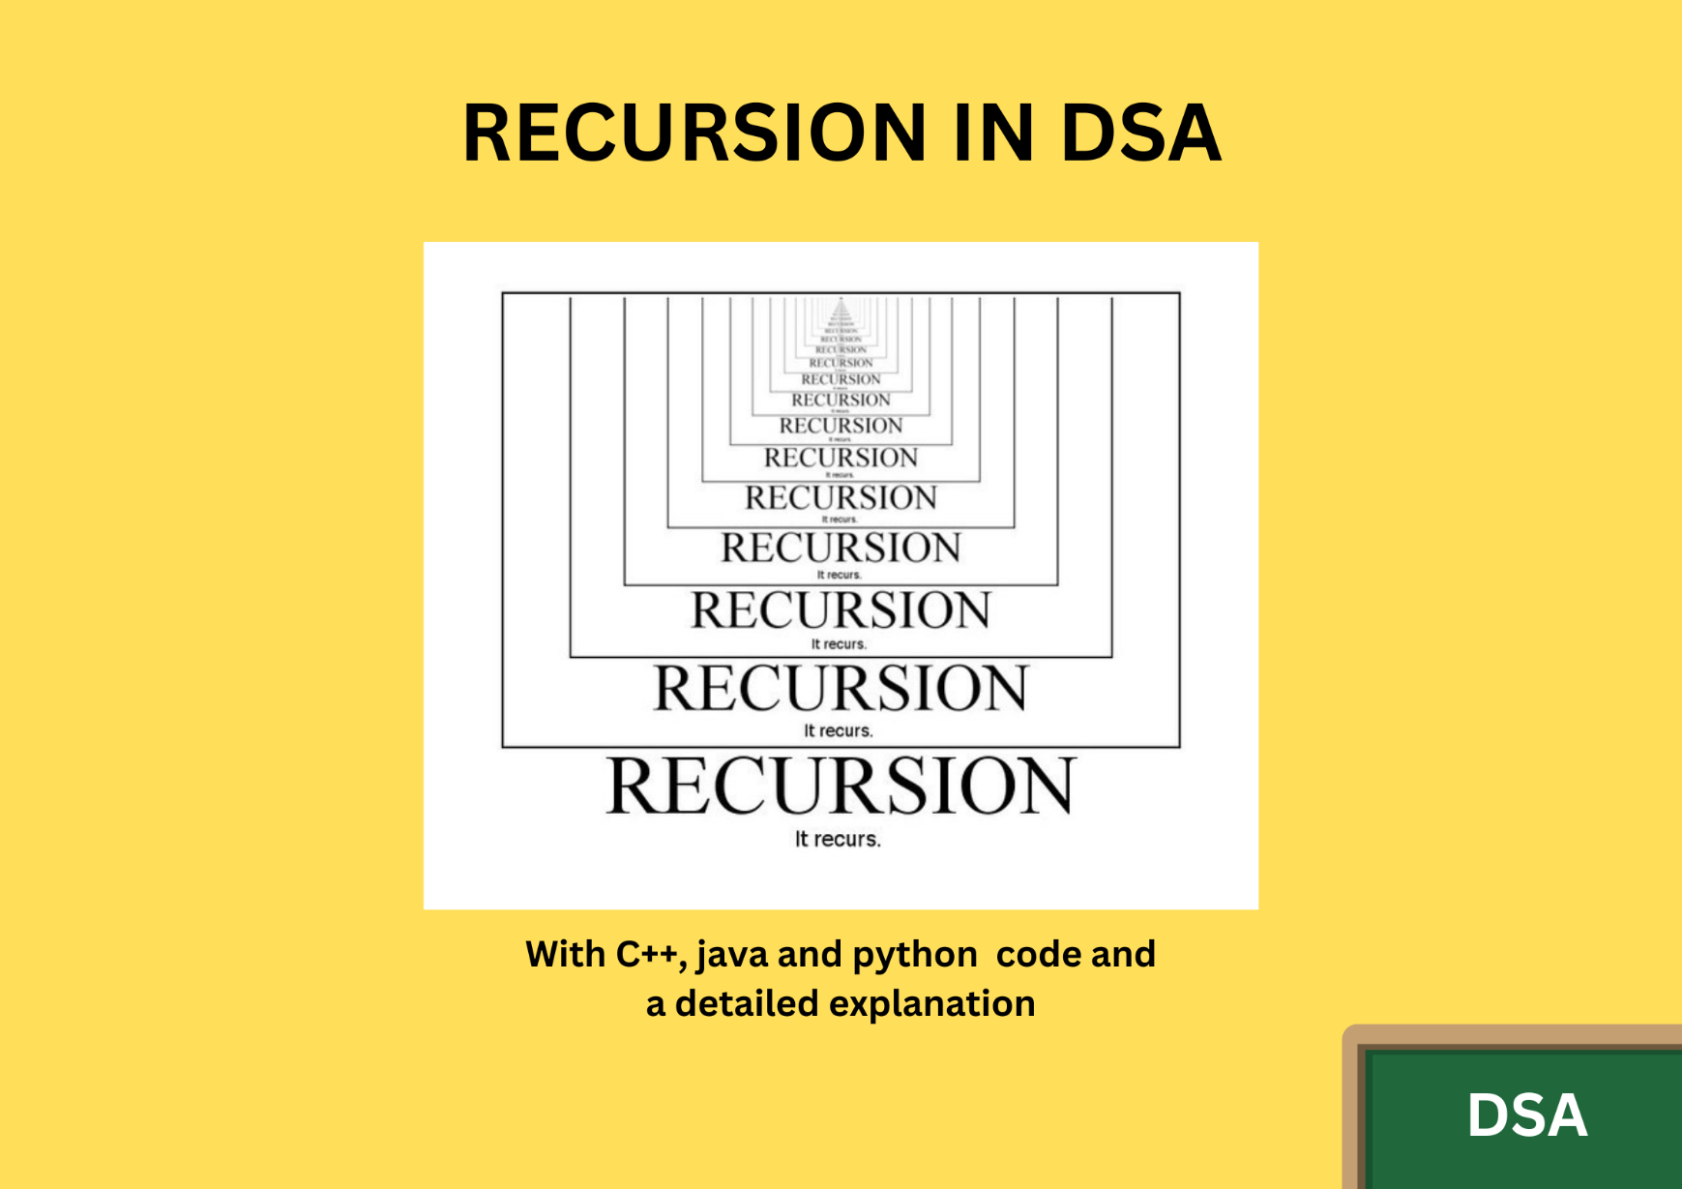

**Example code:**

**def loop(n):**

**if n > 0:**

**print(n)**

**loop(n-1) // same function**

**print(loop(5))**

**Trees**

• A **tree** is a hierarchical data structure consisting of nodes, with a single node called the root and zero or more child nodes.

• **Terminology:**

* **Root:** The topmost node in the tree.
* **Parent:** A node that has one or more child nodes.
* **Child:** A node that has a parent node.
* **Leaf:** A node with no children.
* **Subtree:** A tree formed by a node and its descendants.
* **Depth:** The length of the path from the root to the node.
* **Height:** The length of the path from the node to the deepest leaf.

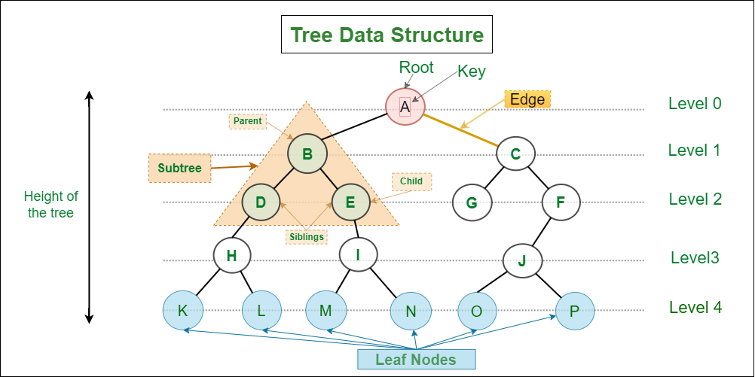

**Graphs**

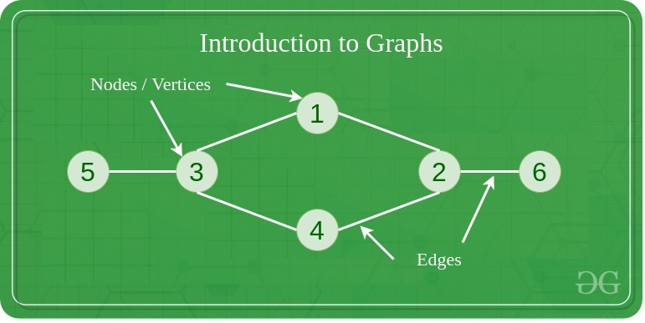

Types of Graph

The graph can be classified into different categories, the most common one is a directed or undirected graph.

**1. Directed graph**A directed graph is a type of graph in which edges are unidirectional or they point towards a particular node to which it connects.

**2. Undirected graph:**An undirected graph is a type of graph in which edges don’t point to either of the attached nodes.

**HashMap**

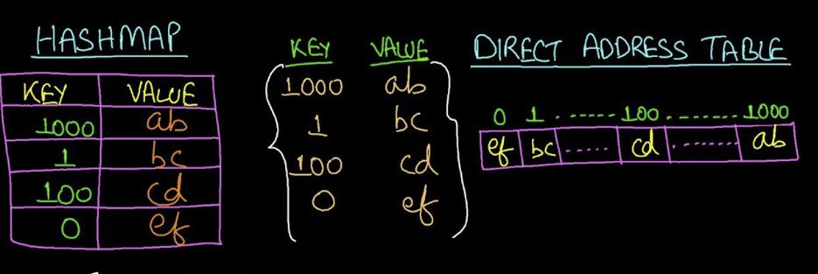

**Common Hash Map Operations**

| **Operation** | **Description** | **Complexity (Average)** |
| --- | --- | --- |
| set | Insert or update a key-value pair | O(1) |
| get | Retrieve the value for a given key | O(1) |
| delete | Remove a key-value pair | O(1) |
| has | Check if a key exists in the map | O(1) |
| size | Get the number of key-value pairs | O(1) |

**Example Use Case**

**What is a Hash Map?**

A **hash map** (or hash table) is a data structure used to store key-value pairs. It allows for quick retrieval of data based on a key, using a hash function to compute an index into an array of buckets or slots. This provides an efficient way to look up, add, and remove items.

In JavaScript, hash maps can be implemented using:

1. **Objects**
2. **Map** (introduced in ES6)

// Creating a hash map using Map

const hashMap = new Map();

// Adding key-value pairs

hashMap.set("name", "John Doe");

hashMap.set("age", 30);

hashMap.set("city", "New York");

// Accessing values using keys

console.log(hashMap.get("name")); // Output: John Doe

console.log(hashMap.get("age")); // Output: 30

// Removing a key-value pair

hashMap.delete("city");

// Checking if a key exists

if (hashMap.has("city")) {

  console.log("City exists in hash map");

} else {

  console.log("City does not exist in hash map");

}

// Iterating over the hash map

for (const [key, value] of hashMap) {

  console.log(`${key}: ${value}`);

}

// Output:

// John Doe

// 30

// City does not exist in hash map

// name: John Doe

// age: 30